**Condition 1:**Newly molted adult, shiny, pale colored shell, fringed with hair, few or no slipper shells

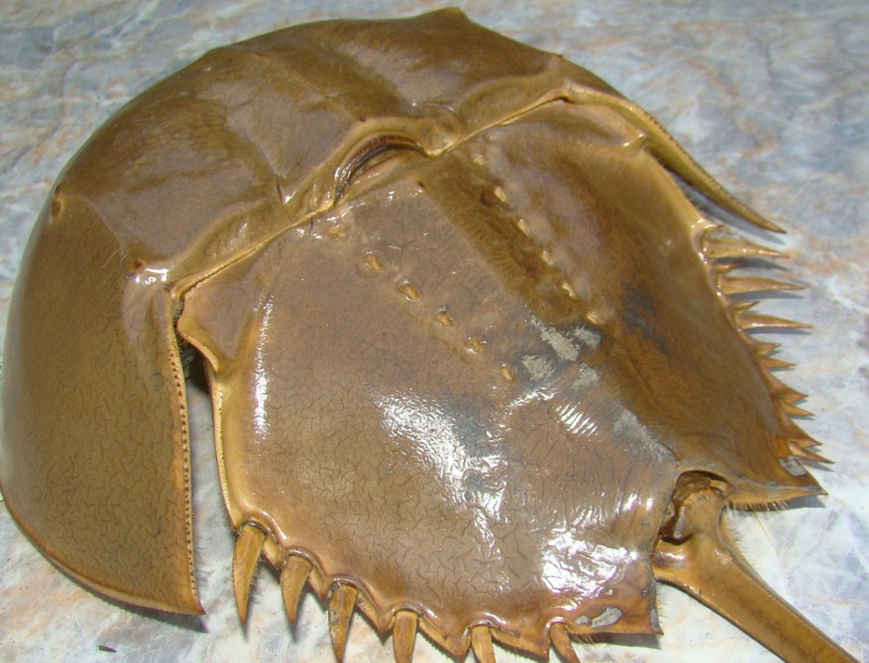

Shell shiny, smooth pale brown coloration, slimy little to no wear

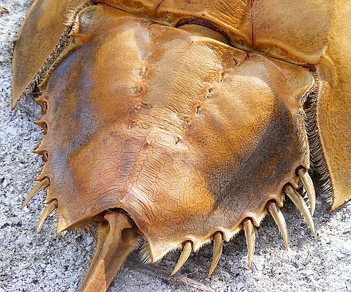

Hairs on the shell

Hair on edge of the shell

**Condition 2:** Middle aged adult, some wear on the shell, a few barnacles, slipper shells or other encrusting organisms, slightly worn telson, little or no hairs on edge of shell

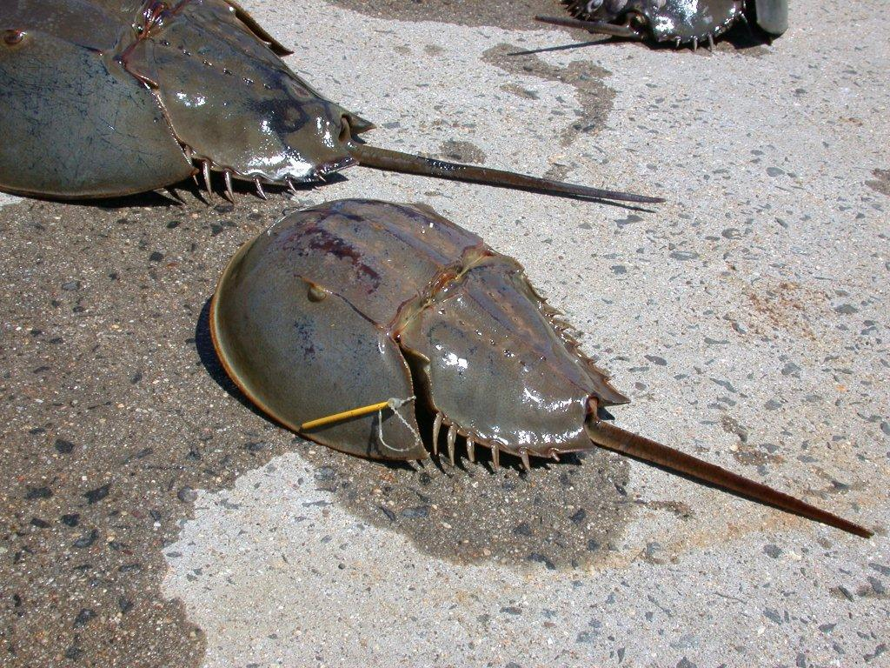

Light wear on the shell

No hair on edge of shell

n

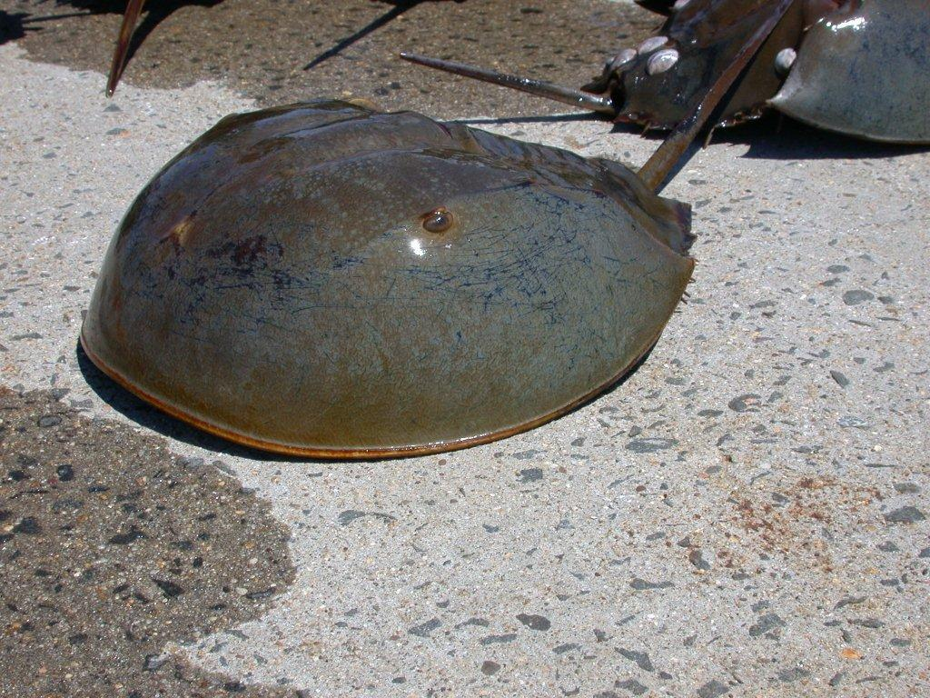

Scratches on the shell

Some shell shine

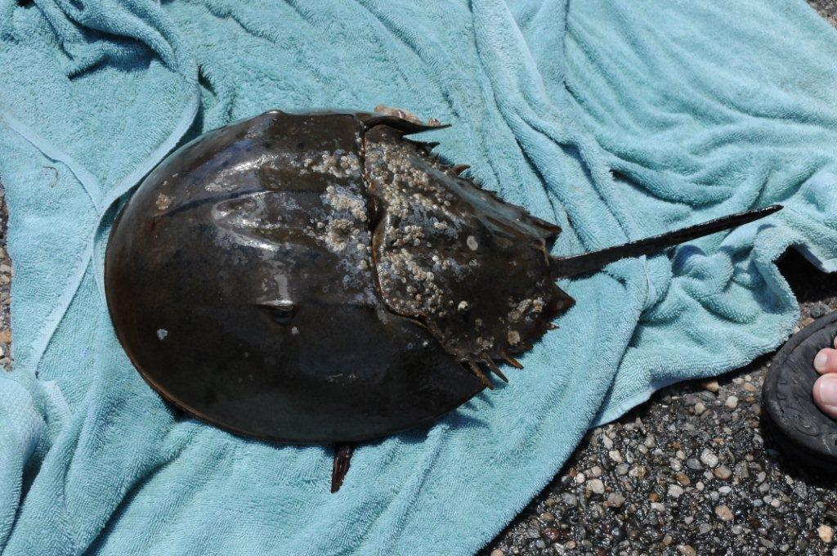

Some encrusting organisms

**Condition 3:** Old age, dark, pitted shell, no shine, lots of encrusting organisms, shortened telson.

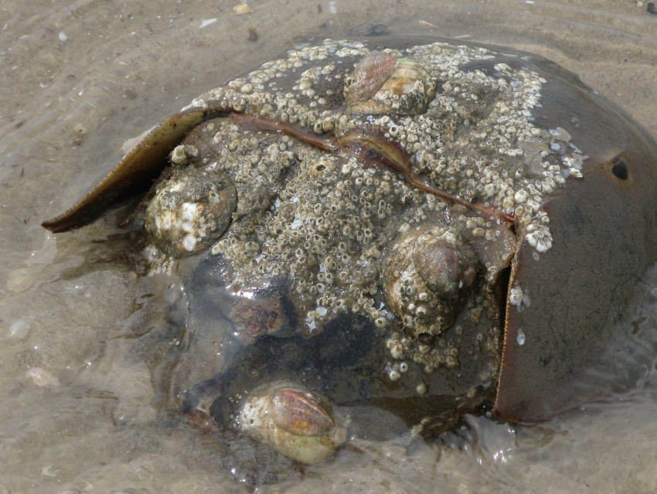

Extensive encrusting organisms

Very dark pitted eye

Extensive encrusting organisms

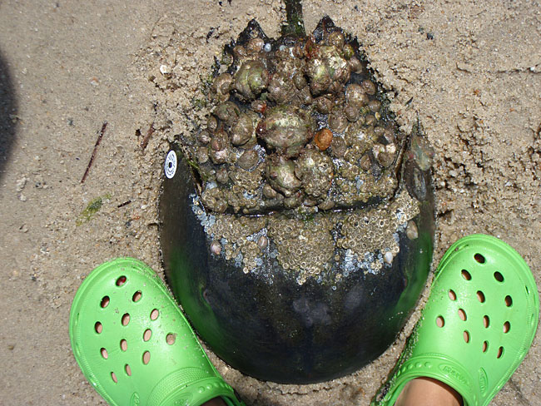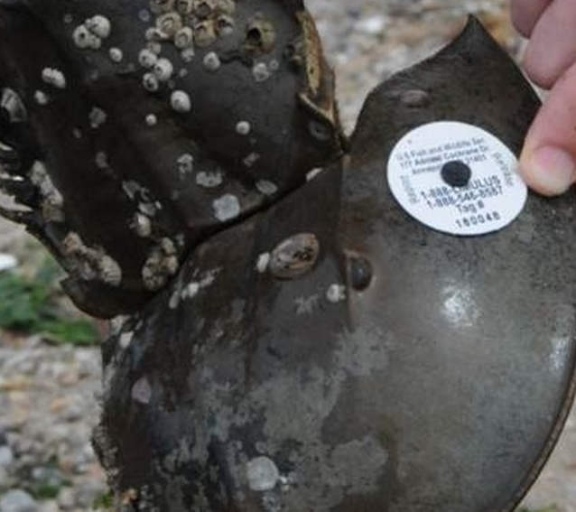

Very dark, pitted, scratched shell

No shell shine